The Congregational Church of the United Church of Christ
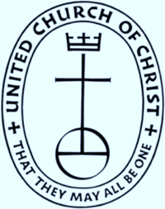
P.O. Box 387
Bradford VT 05033
www.bradforducc.org
Rev. Thomas C. Kinder
Interim Pastor
bradfordvtucc@gmail.com

March 1, 2017

Dear Church Members:

WARNING: A Congregational Meeting will take place immediately following the worship service on March 26, 2017 to consider the following question posed by the Diaconate:

“Shall the Congregational Church of the United Church of Christ, Bradford, Vermont declare itself to be an Open and Affirming Congregation of the UCC by adopting an Open and Affirming Covenant and Implementation Plan?”

Please see the Covenant and Implementation Plan attached with this letter

Sincerely,

Barbara Joslyn

Barbara Joslyn
Clerk

.

